Students will be able to use set formulas to recognize invalid credit card numbers and UPC codes.

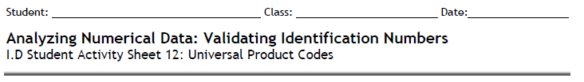

Turn to page 31 in your Book.
The Check Digit is chosen so that the calculation described previously totals a number whose final digit is 0. In the UPC number the check digit is d, for which the sum is as follows:

ends in 0. In this weighted sum, the weights are: {3, 1, 3, 1, 3, 1, 3, 1, 3, 1, 3, 1}.
When entering a code number, the single digit error is most common (for example, keying in 8 instead of 3). Another common error is the transposition error, where the order of two adjacent digits is reversed (for example, writing 83 instead of 38). Systems have been established to detect and correct (when possible) these and other errors almost immediately.

1. Show that 0-58200-48826-5 is a valid UPC number.

2. Show that 0-52200-48826-5 is an invalid UPC number.

If someone made a single digit error when entering this invalid number, can you tell which digit is incorrect? Why or why not?

Change one digit in #2 so that it is a valid UPC number.

3. Determine the check digit (d) for the UPC number 38137009213d.

4. Suppose you entered 8 instead of 9 when recording the UPC 1 55210 02149 6. Explain why the UPC method will detect this error.

Turn to page 34 in your book.
5. Master card numbers begin with 51, 52, 53, 54, or 55. What is the maximum number of credit cards that MasterCard can have?

The credit card companies use the Codabar method to determine the check digit. This method consists of the following steps:
- Add the digit in the odd-numbered positions and double the total
- Add the quantity of odd-position digits that are more than 4 to that total
- Add the even-position digits
- Choose a check digit that makes this calculation total a number whose final digit is 0.

Libraries, shipping/receiving companies, and blood banks also use the Codabar method.
2. Find the check digit (d) for the Visa card 4162 0012 3456 789d

3. Find the check digit (d) for the MasterCard number 5424 9813 2720 008d

4. Is 4128 0012 4389 0110 a valid Visa credit card number?

